

**AMERICAN INTERNATIONAL UNIVERSITY-BANGLADESH**

**Faculty of Engineering**

Lab Report

**Experiment # 07**

**Experiment Title:** Interfacing the Arduino with an external sensor using serial communication protocol for implementing an obstacle detection system

|  |  |  |  |
| --- | --- | --- | --- |
| **Date of Perform:** | 06 MAY 2025 | **Date of Submission:** | 13 MAY 2025 |
| **Course Title:** | Microprocessor and Embedded Systems Lab | | |
| **Course Code:** | EEE4103 | **Section:** | Q |
| **Semester:** | Spring 2024-25 | **Degree Program:** | BSc in CSE |
| **Course Teacher:** | **PROTIK PARVEZ SHEIKH** | | |

**Declaration and Statement of Authorship:**

1. I/we hold a copy of this Assignment/Case Study, which can be produced if the original is lost/damaged.
2. This Assignment/Case Study is my/our original work; no part has been copied from any other student’s work or any other source except where due acknowledgment is made.
3. No part of this Assignment/Case Study has been written for me/us by any other person except where such collaboration has been authorized.

by the concerned teacher and is acknowledged in the assignment.

1. I/we have not previously submitted or am submitting this work for any other course/unit.
2. This work may be reproduced, communicated, compared, and archived to detect plagiarism.
3. I/we permit a copy of my/our marked work to be retained by the Faculty Member for review by any internal/external examiners.
4. I/we understand that Plagiarism is the presentation of the work, idea, or creation of another person as though it is your own. It is a form of cheating and is a very serious academic offense that may lead to expulsion from the University. Plagiarized material can be drawn from, and presented in, written, graphic, and visual forms, including electronic data, and oral presentations. Plagiarism occurs when the origin of the source is not appropriately cited.
5. I/we also understand that enabling plagiarism is the act of assisting or allowing another person to plagiarize or copy my/our work.

*\* Student(s) must complete all details except the faculty use part.*

** Please submit all assignments to your course teacher or the office of the concerned teacher.

|  |  |  |  |  |  |  |
| --- | --- | --- | --- | --- | --- | --- |
| **Group # 08** | | | | | | |
|  |  |  |  | | |  |
| **Sl No** | **Name** | **ID** | **PROGRAM** | | | **SIGNATURE** |
| 1 | **MD. ABRAR RAFID SHARIAR** | **22-48055-2** | **BSc in CSE** | | |  |
| 2 | MD TANJIL TASHRIK ZIM | 22-48021-2 | BSc in CSE | | |  |
| 3 | MD. AL-IMRAN SAYEM | 22-48023-2 | BSc in CSE | | |  |
| 4 | HUMAIRA ZANNAT | 22-47789-2 | BSc in CSE | | |  |
| 5 | SANJUKTA DAS | 22-47801-2 | BSc in CSE | | |  |
| ***Faculty use only*** | | | | | | |
| FACULTY COMMENTS | | | | **Marks Obtained** |  | |
|  | | | |
| **Total Marks** |  | |

# Table of Contents

|  |  |
| --- | --- |
| Objectives |  |
| Equipment List |  |
| Circuit Diagram |  |
| Experimental Output Results (Color Photographs) |  |
| Simulation Output Results (Color Photographs) |  |
| Answers to the Questions in the Lab Manual |  |
| Discussion |  |
| References |  |

**Marking Rubrics (to be filled by Faculty):**

|  |  |  |  |  |  |  |
| --- | --- | --- | --- | --- | --- | --- |
| **Level Category** | **Excellent**  **[5]** | **Proficient**  **[4]** | **Good**  **[3]** | **Acceptable**  **[2]** | **Unacceptable**  **[1]** | **No Response**  **[0]** |
| **Title and Objectives** | Able to clarify the understanding of the lab, no issues are missing and formatting is good. | Able to clarify the understanding of the lab experiment, no issues are missing but its formatting is not good. | Able to clarify the understanding of the lab experiment, but a few issues are wrong, and its formatting is bad. | Able to clarify the understanding of the lab experiment, but it lacks a few important issues of the experiment without maintaining the format. | Unable to clarify the understanding of the lab experiment. | No Response/ copied from others/ identical submissions with gross errors/image file printed |
| **Codes and Methods** | Able to explain the experimental codes and simulation methods using Proteus very well. | Able to explain the experimental codes and simulation methods using Proteus but is not formatted well. | Able to explain the experimental codes but simulation method using Proteus is not explained well. | Presents the experimental codes but didn’t explain simulation methods using Proteus clearly. | Presents the experimental codes but didn’t explain simulation methods using Proteus. |
| **Results** | Key results and images are there. Figures/Tables have all identifications and refer to them properly in the texts. | Key results and images are there. Figures/Tables have all identifications, such as the axis labels, numbers, and captions with a few minor errors; the texts refer them. | Key results and images are there. Figures/Tables lack a few identifications, such as the axis labels, numbers, and captions; the texts refer them. | Misses several key results and images. Figures/Tables lack identification, such as the axis labels, numbers, and captions; the texts don’t refer them. | Major results, such as experimental and simulation results’ images are not included. Figures and tables are poorly  constructed or not presented. |
| **Discussion and Conclusion** | Proper interpretation of results and summarizes the results to draw a conclusion, discusses its applications in real-life situations to connect with the report’s conclusion. | Proper interpretation of results and summarizes the results to draw a conclusion but didn’t discuss its applications in real-life situations to connect with the conclusion of the report. | Interpretation of results is presented. However, there is a disconnect between the results and discussion. | Misses the interpretation  of key results. There is little connection between the results and discussion. | Very poor interpretation of  the results. No connection  between results and discussions. |
| **Question and Answer** | Able to produce all questions’ answers correctly maintaining the lab report format. | Able to produce all questions’ answers but didn’t maintain the lab report format. | Able to produce all questions’ answers but wrong answers to a few questions. | Able to produce all questions’ answers but wrong/missing answers to multiple questions. | Unable to produce all questions’ answers and completely wrong answers. |
| **Comments** |  | | | | | **Total Marks (25)** |

**Objectives:**

The objectives of this experiment are to

1. Write code for a simple obstacle detection system in Arduino IDE.
2. Implement a simple obstacle detection system using an Arduino microcontroller.

# Equipment List:

# Arduino IDE

# Arduino UNO

# Sonar Sensor

# Breadboard

# LEDs

# Resistor

# Jumper Wires.

# Circuit Diagram:

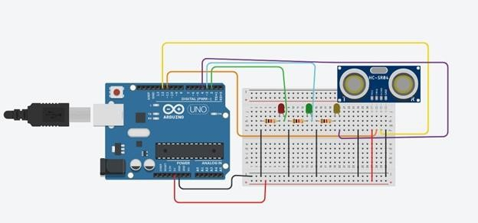

**Figure 1:** Experimental setup of an obstacle detection system using Arduino

**Experimental Output Results:**

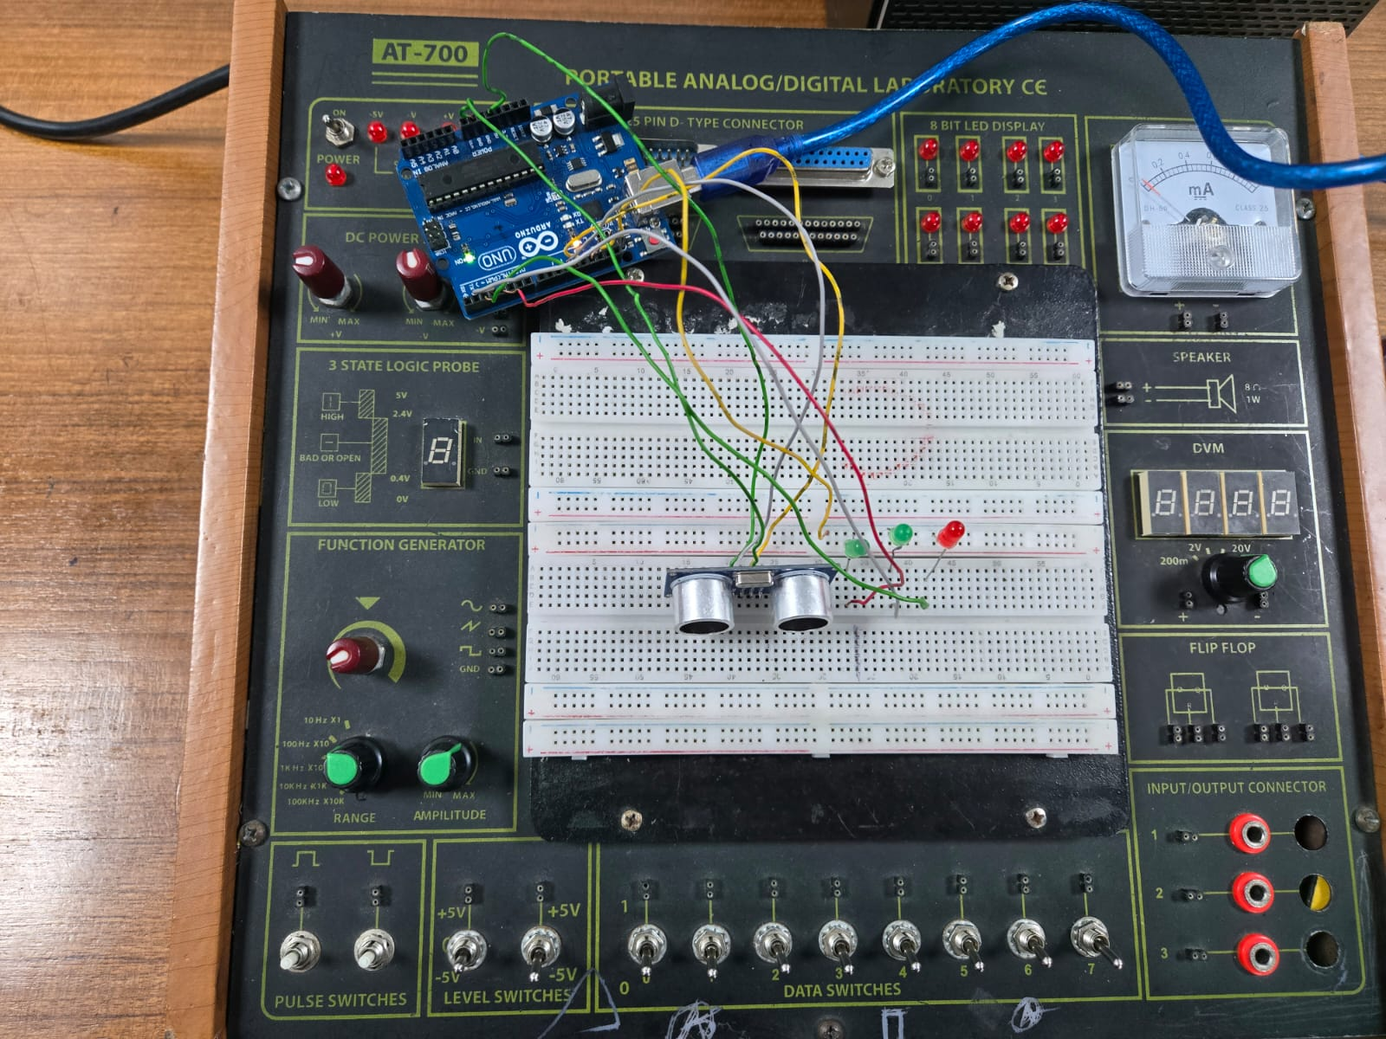

**Figure 2:** Hardware implementation of an obstacle detection system using Arduino

Explanation:

In this experiment, a object detection system was created using a sonar system and some LEDs. An Arduino Uno board was taken. The sonar was connected with the Arduino Uno board. The VCC of the sonar was connected with the 5V pin of the Arduino Uno Board, The GND of the sonar was connected with the GND pin of the Arduino Uno board. The Trig of the sonar was connected with pin 11 of the Arduino Uno. At the end, the Echo of the sonar was connected with pin 12 of the microcontroller. To express the distance of the object from the sonar, three lights were set with the Arduino Uno board at the following pin 2, 3 and 4. Each of these LEDs indicated if an object was a far distance, medium distance or close distance if it was within the range of the sonar. All of these LEDs were grounded using resistors.

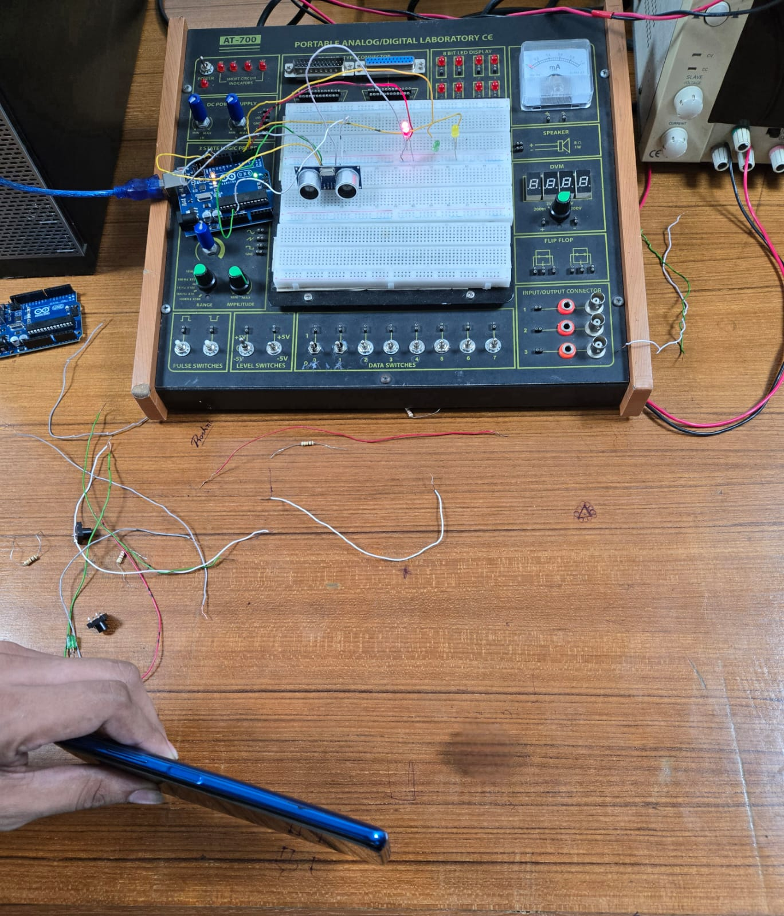

**Figure 3:** RED LED turned ON when distance as at a far distance

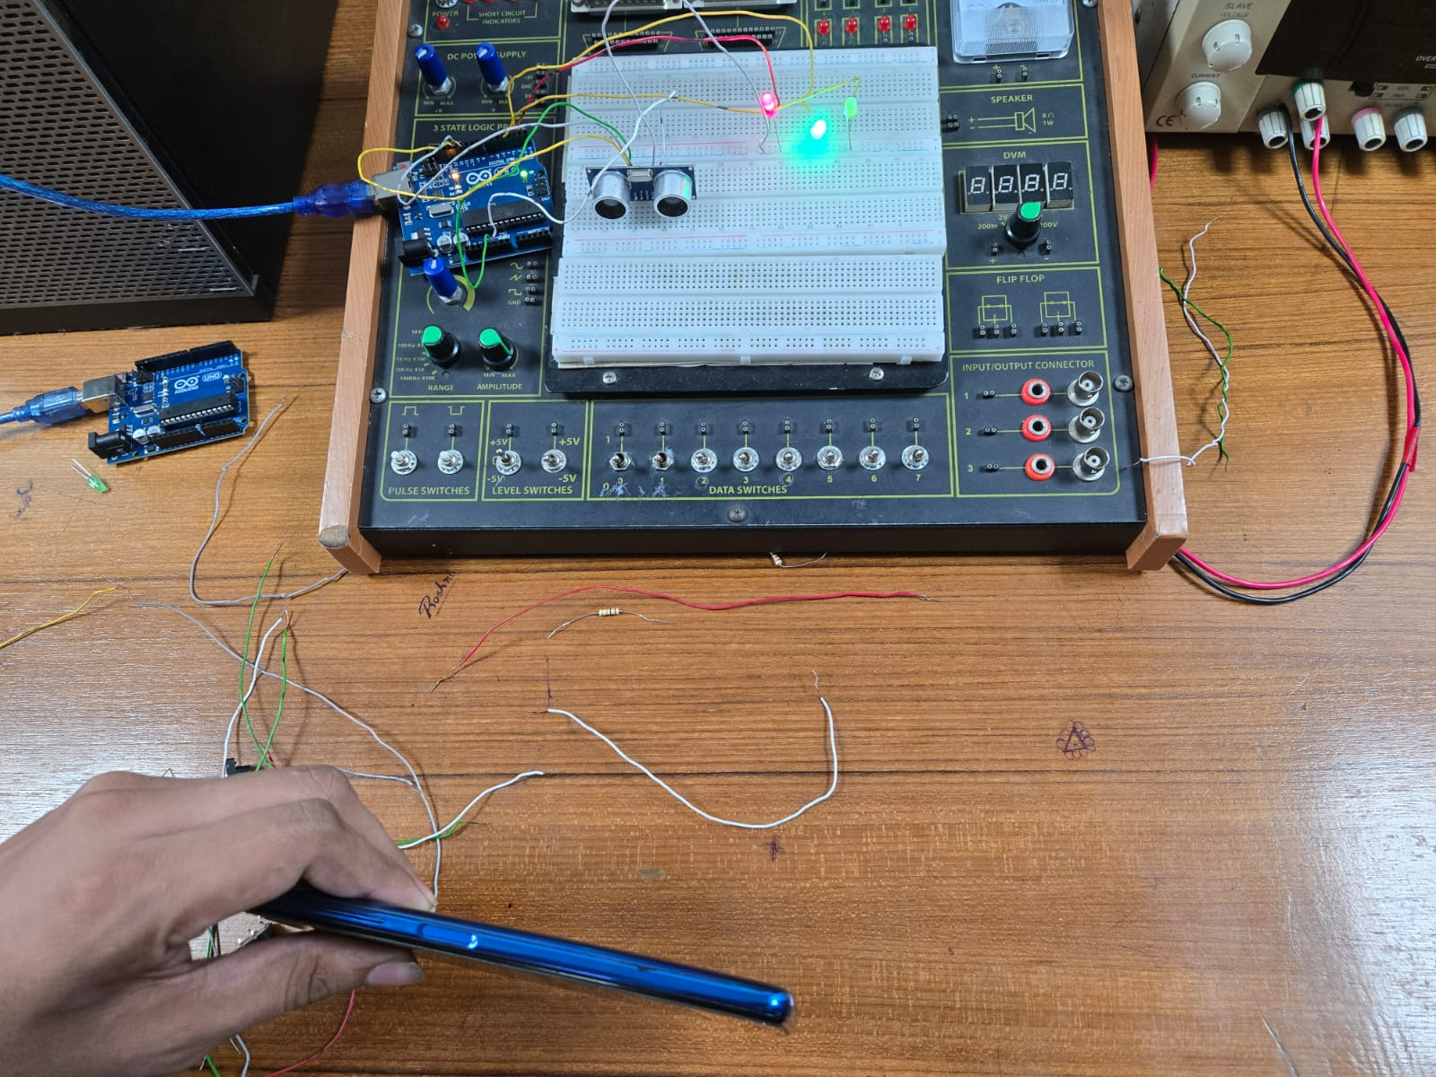

**Figure 4:** YELLOW LED turned ON when a distance as at a medium distance

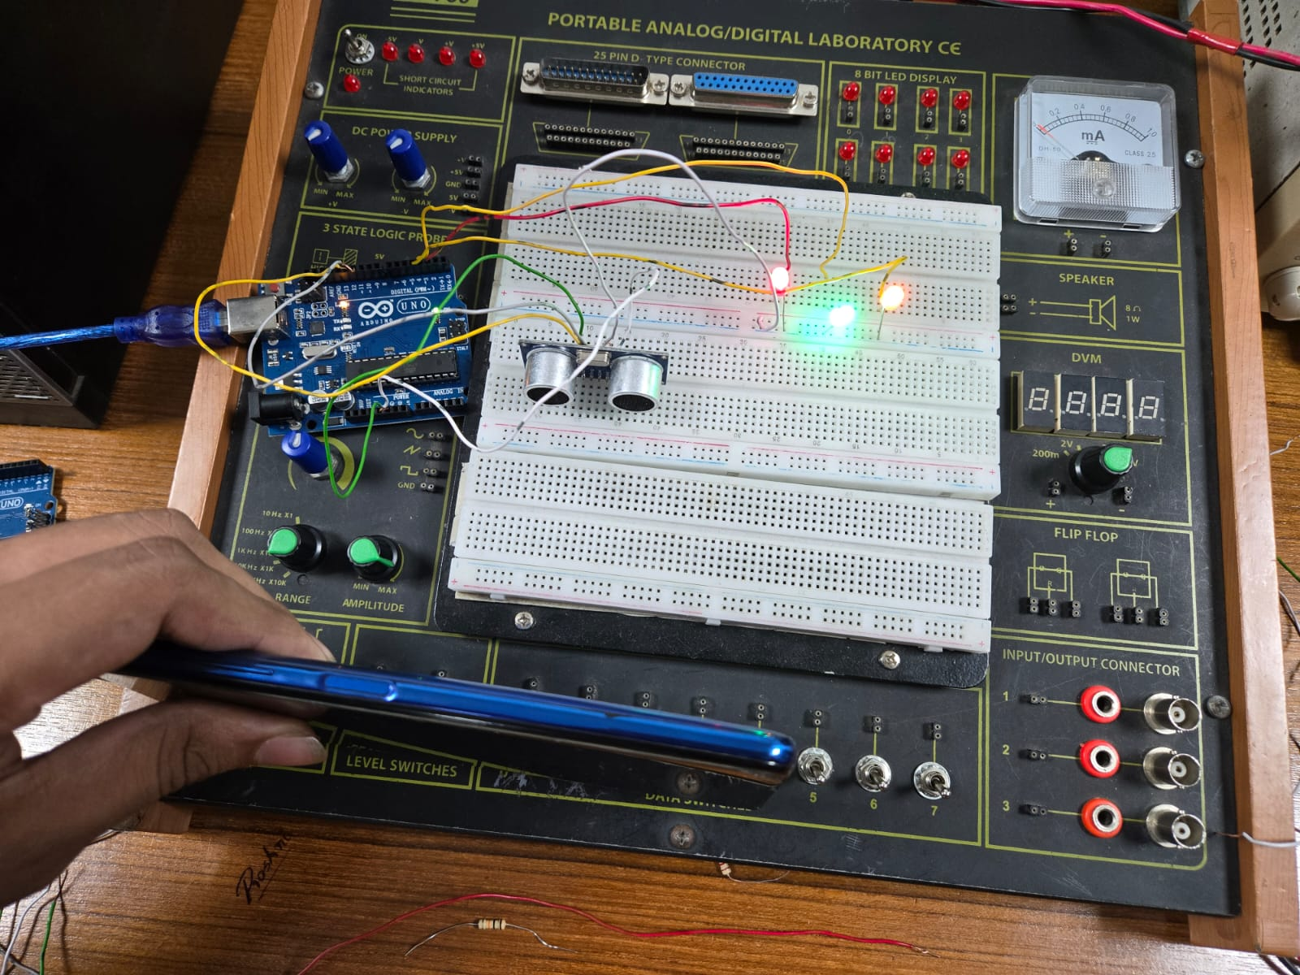

**Figure 5:** GREEN LED turned ON when a distance as at a close distance

Explanation:

In this experiment, as the circuit was operating, an object was placed in front of the sonar sensor. When the object was detected at a far distance within the sensor's range, only the RED LED lit up. At that point, the serial monitor displayed the measured distance in both centimeters and inches. As the object moved closer to the sonar, reaching a medium range, the YELLOW LED also turned on, indicating a shorter distance. The serial monitor continued to display the updated distance readings. When the object was brought very close to the sonar, the GREEN LED was activated, showing the closest range, and the corresponding distance was again shown on the serial monitor

**Simulation Output Results:**

# Figure 6: First LED ON in Proteus Simulation when the object was far away

# Figure 7: Second LED ON in Proteus Simulation when the object was in Medium Distance

# Figure 8: Third LED ON in Proteus Simulation when the object was in Close Distance

# Explanation:

# In this experiment, Proteus Simulation Software was used to verify the results obtained during the test. The circuit was first designed in Proteus according to the required specifications. After developing the circuit, the Arduino HEX file was generated using the Arduino IDE and then imported into the Proteus simulation environment. The behavior of the circuit was observed by moving the cursor near the sonar sensor. The results were analyzed based on the activation of the LEDs, which indicated the distance of the object from the sensor.

**Answer of the Question of Lab Manual:**

1. **Code:**

// define the pin numbers

const int trigPin = 11;

const int echoPin = 12;

// define variables

long duration;

float distance, distanceInches, distanceThreshold;

void setup() {

Serial.begin(9600); // Starts the serial communication

pinMode(trigPin, OUTPUT); // Sets the trigPin as an Output

pinMode(echoPin, INPUT); // Sets the echoPin as an Input

pinMode(2, OUTPUT); // Sets pins 2, 3, and 4 as the Output pin

pinMode(3, OUTPUT);

pinMode(4, OUTPUT);

}

void loop() {

// Clears the trigPin

digitalWrite(trigPin, LOW);

delayMicroseconds(2);

// Sets the trigPin on HIGH state for 10 microseconds

digitalWrite(trigPin, HIGH);

delayMicroseconds(10);

digitalWrite(trigPin, LOW);

// Reads the echoPin, returns the sound wave travel time in microseconds

duration = pulseIn(echoPin, HIGH);

// Calculating the distance

distance = (duration/2) * 1e-6 * 340 * 100;

distanceinches = (distance / 2.54);

// Prints the distance on the Serial Monitor

Serial.print("Distance = ");

Serial.print(distance);

Serial.print(“cm; ”);

Serial.print("Distance = ");

Serial.print(distanceinches);

Serial.println(“inches”);

// set threshold distance to activate LEDs

distanceThreshold = 80;

if (distance > distanceThreshold) {

digitalWrite(2, LOW);

digitalWrite(3, LOW);

digitalWrite(4, LOW);

}

if (distance < distanceThreshold && distance > distanceThreshold-30) {

digitalWrite(2, HIGH);

digitalWrite(3, LOW);

digitalWrite(4, LOW);

}

if (distance < distanceThreshold-30 && distance > distanceThreshold-50) {

digitalWrite(2, HIGH);

digitalWrite(3, HIGH);

digitalWrite(4, LOW);

}

if (distance < distanceThreshold-50 && distance > distanceThreshold-70 ) {

digitalWrite(2, HIGH);

digitalWrite(3, HIGH);

digitalWrite(4, HIGH);

}

delay(200); // Wait for 200 millisecond(s)

}

Explanation:

This Arduino code is designed to measure the distance of an object using an ultrasonic sensor and visually indicate that distance using three LEDs. The trigPin sends out an ultrasonic pulse, and the echoPin receives the reflected pulse. The time it takes for the echo to return is measured and used to calculate the distance of the object in both centimeters and inches. These values are then printed on the Serial Monitor for reference. Based on the measured distance, the code controls three LEDs connected to pins 2, 3, and 4. When the object is far away, all LEDs remain off. As the object moves closer, one LED turns on, followed by a second, and finally a third as the object comes very close to the sensor. This tiered lighting system provides a simple visual cue for distance, with more LEDs lighting up as the object approaches. The code runs continuously in a loop, checking the distance and updating the LED status accordingly.

1. **Simulatioins:**

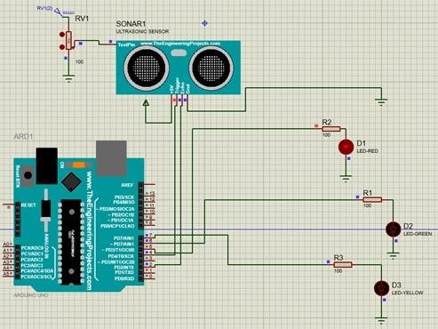

**Figure 9:** First LED ON in Proteus Simulation when the object was far away on the modified code

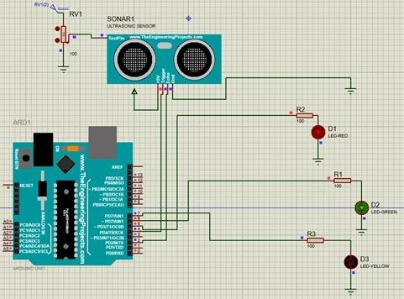

**Figure 10:** Second LED ON in Proteus Simulation when the object was in medium distance on the modified code

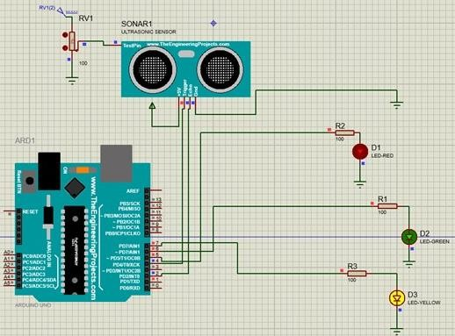

**Figure 11:** Third LED ON in Proteus Simulation when the object was in Close Distance on the modified code

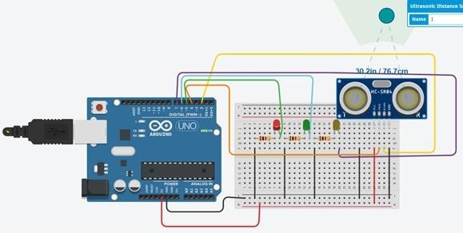

**Figure 12:** First LED ON in TinkerCad Simulation when the object was far away on the modified code

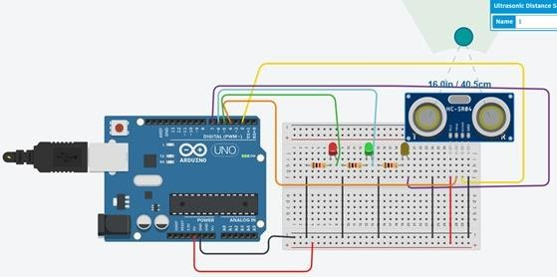

**Figure 13:** Second LED ON in TinkerCad Simulation when the object was in medium distance on the modified code

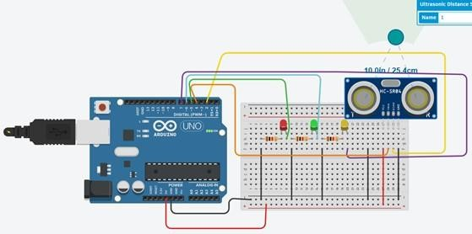

**Figure 14:** Third LED ON in TinkerCad Simulation when the object was in close distance on the modified code

# Discussion:

# In this experiment, a sonar sensor was used to detect the distance of an object or obstacle and the distance between the object and sonar was displayed using the LEDs that were connected. The sonar sensor that was used in this experiment were studied carefully before using it. The pin operations and how the sonar works were observed and carefully understood. After that, the sonar sensor was set accordingly with the Arduino Uno board accordingly. The LEDs were set as per necessity. After that, the circuit was operated and the systems operations were observed. The method of how the system was detecting the distance between the object and sonar were observed. The method of how it was performed using Trigger and Echo was observed accordingly as well and co-related with the experiment’s working methodology. The LEDs were turning ON accordingly based on the distance and formulas that were set on the code. Changes in the detection mechanism was also observed by changing the detecting parameters accordingly. All the results that were observed were carefully noted down for further evaluation. The similar system was developed on the simulation softwares like Proteus and TinkerCad. The results that were obtained on the physical operation were evaluated with the simulated outcomes. There were some minor discrepancies that were observed. The distance that were generated on the simulation’s serial monitor were a bit different compared to the ones that were observed on the physical testing. This might be caused due to minor system and human errors. This caused the inconsistencies in the values of the serial monitor. Moreover, the detecting rate of the system in the physical environment and simulation virtual environment were a bit different. This was ruled as normal as human error was general in the physical world. From the observation it can be said that after both hardware and software implementation showed the expected outcomes and the experimental objectives was achieved.

# References:

[1] Arduino IDE, https://www.arduino.cc/en/Main/Software accessed on May 3, 2019.

[2] Arduino and Proteus Library, https://etechnophiles.com/add-simulate-ultrasonic-sensorproteus-2018-edition/ accessed on May 3, 2019.

[3]Ultrasonic Distance Sensor in Arduino With TinkerCad https://www.instructables.com/id/Ultrasonic-Distance-Sensor-Arduino-Tinkercad/ accessed on May 3, 2019